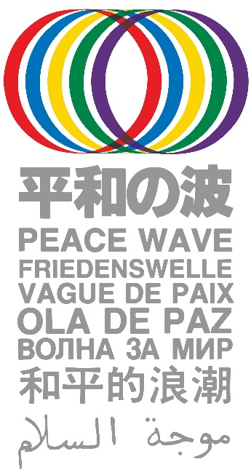
Please send the information of your Peace Wave
Action from August 6 to 9 to: Peace Wave Action
Committee: antiatom@topaz.plala.or.jp

Name of the event/action: __________________________

Time/ Date: _____________________________________

Place: __________________________________________

City/Town: ________________ Country: _______________

Organizer: ________________________________________________________

Contact person: ___________________________________________________

Email address_____________________________________________________

URL: ___________________________________________________________

Other SNS: ______________________________________________________

Short description of planned action(s) for the Peace Wave:

Contact: antiatom@topaz.plala.or.jp URL: http://www.antiatom.org/english/

